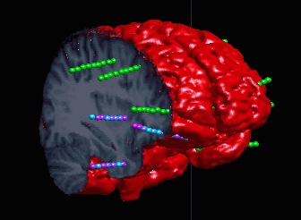 **Imaging Suite Manual** 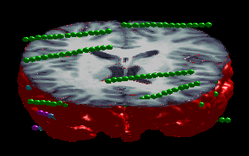

1. **Introduction**

This manual outlines the functions of the imaging suite. The purpose of the program is to semi-automate the processes required to organise, orientate and view medical imaging for uses in neuroscience, particularly for Stereo-Electroencephalography.

1. **Subject Details**

This button opens a dialog to create subjects and import their relevant medical imaging.

* 1. **Creating a new Subject**

On the Imaging Menu select “Subject Details”. This will open a dialog box for entering new subject details.

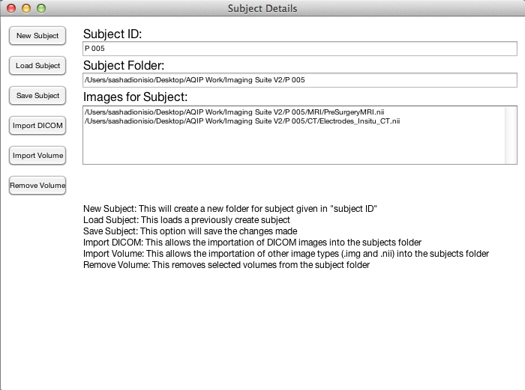

Subject ID: This field is the name of the folder that will contain all of the imported and created files for the following steps. A default subject ID “P001” is pre-filled.

Click on “New Subject”. This will ask for where to save the folder for our new subject. This will now create the Subject folder in the specified location.

* 1. **Importing DICOMs**

Select “Import DICOM”. This will open up a dialog box for entering the type of image and a unique name for the image. The unique name is how the image will then be referenced from within the program.

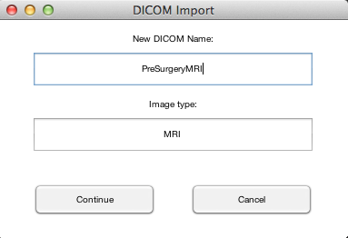

Select “Continue”. This will open a prompt to select the DICOM images for importation.

* 1. **Importing a Volume (.nii and .img)**

Select “Import Volume”. This will open up a dialog box for entering the type of image and a unique name for the image. The unique name is how the image will then be referenced from within the program.

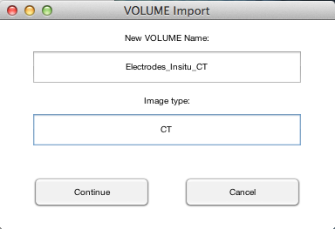

Select “Continue”. This will open a prompt to select the .nii and .img images for importation.

* 1. **Removing a Volume**

To remove a image from the subject select it from the “Images for the Subject” box then select “Remove Volume”.

* 1. **Saving the Subject**

The changes (Importation, deletion, or creation) all need to saved. Before closing the Subject Details dialog box please save the subject by selecting “Save Subject”.

1. **Volume Adjustment**

This button opens a dialog box that facilitates the alignment of multimodal imaging.

Initially the dialog box only lists the images that have been imported. Selection of an image from the list makes visible a series of buttons that semi-automates the alignment procedure.

* 1. **Selecting the Anterior Commissure**

If the selected Images are MRI’s, the “Automatically select AC” button can fully automate this procedure.

If the selected images are not MRI’s then manual selection of the anterior commissure is required. Manual selection will open a 2D viewer with instructions on selection of the AC.

Instructions:

Select the AC onscreen.

Click “Set origin”

Click “Reorient”

Click “Done” (This saves the reorientation over the original file)

Click “no” (We do not need the reorientation matrix)

Close the window.

The AC must be selected for all images that are going to be aligned.

* 1. **Aligning Images**

To begin aligning images, select all images (in the volumes list) that are to be aligned.

In the “Coregister volumes to” drop down select the image that the selected images will now be aligned too.

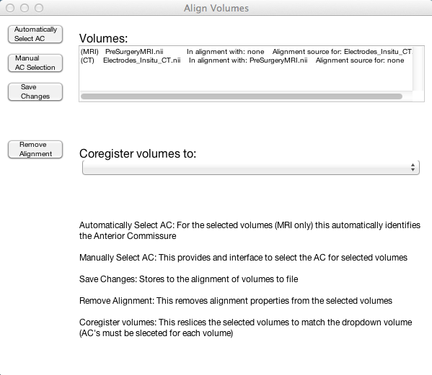

Save the changes.

1. **Two Dimensional Imaging**

This button opens a dialog box that allows the view of multiple images (In overlay) in a multi-planar view. Functionality is provided by a series of checkboxes on the top of the panel.

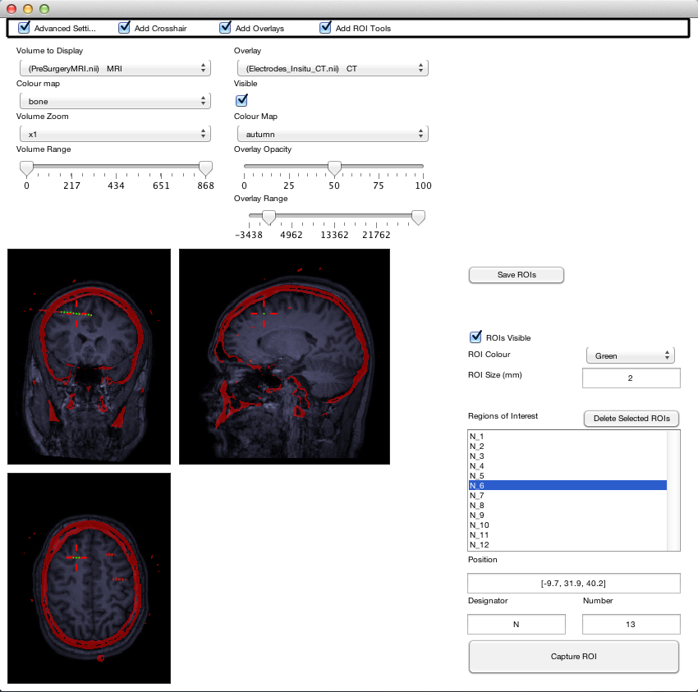

* 1. **Advanced settings**

This checkbox provides a series of options that control the primary image.

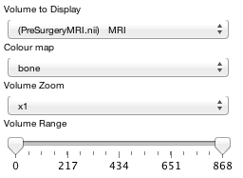

* 1. **Cross Hair**

This checkbox provides a small red crosshair centered on the point of interest.

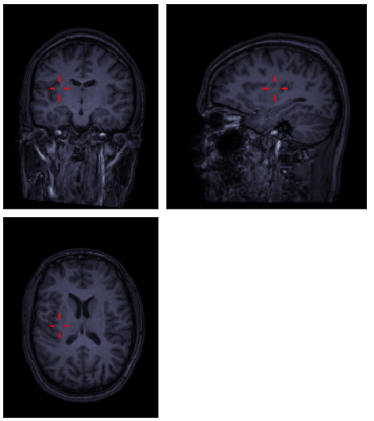

* 1. **Add overlay**

This checkbox provides the option to add overlays and adjust their settings similar to the primary image.

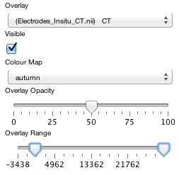

* 1. **Add ROI tools**

This checkbox provides an interface to mark regions of interest.

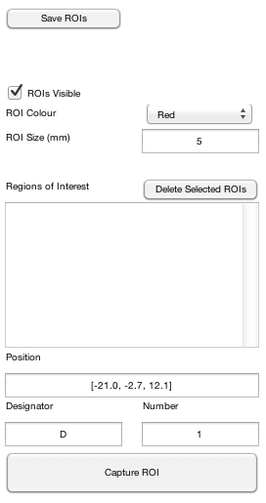

Clicking on “Capture ROI” places a ROI at the crosshair position, which is given in the “position” field of the ROI tools. The ROIs will identified by a designator and Number separated by an underscore in the “Regions of Interest” list. This list should be save at the end of marking ROIs.

1. **Three Dimensional Imaging**

This button provides a dialog box that facilitates a three dimensional view of the volumes, surfaces, ROIs, labels and external data available to the subject. Functionality is provided by a series of checkboxes located on the top of the panel.

* 1. **Plane Limits**

Three plane limit sliders control the visible portion of the selected data for the following check boxes. The sliders are only visible with active data to display and update when new options are selected.

* 1. **2D Volume**

This checkbox provides a series of options to view a 2D image cast into 3D as a set of 6 cuts. If the Sliders are at their maximum/minimum values that plane will become invisible.

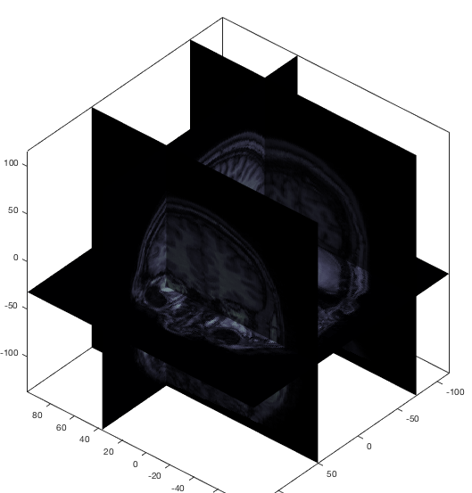

If a 3D surface is also checked then the 2D slices will be masked so that they fit flush with the surfaces edges.

* 1. **3D Volume**

This checkbox provides the option to view surfaces.

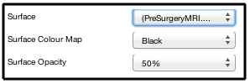

* + 1. **To create a volume surface (Only for MRIs)**

Check the “3D Surface” checkbox.

Select a surface from the “Surface” drop down menu.

If a surface has not been created for the selected image a prompt to create it will occur.

If the surface has already been made then it will simply be loaded and displayed.

* + 1. **Masked 2D image flush mounted with 3D surface**

When a 3D surface is created a second “mask” for the surface is also created. This mask is applied when the 3D surface and 2D volume checkboxes are both selected.

Using the mask, all 2D images are trimmed to best match the surfaces boundaries and are presented as flush edges to the surface.

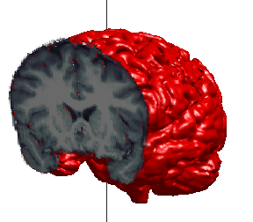

* 1. **ROIs**

This checkbox provides the options to view saved ROIs.

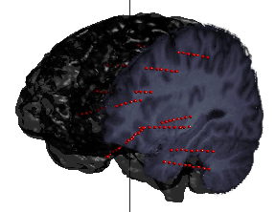

* 1. **ROI Labels**

This checkbox provides the options to view the designators for all of the ROIs (With or without the ROIs present).

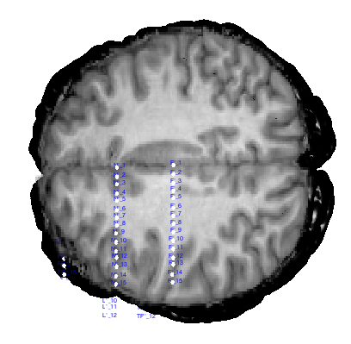

* 1. **External Data**

This checkbox provides the options to load and view external data overlaid on the ROIs.

* + 1. **Loading external data**

To view external data on the ROIs the data must be in to correct format.

The data must be saved as a .mat file. The file must contain in a structure called “DataStructure” with fields “Label” and “Data”.

The Label field must be in the format Designator_Number, identical to ROIs. The Labels in the DataStructure are then matched with the ROIs marked within the 2D interface. ROIs not populated by external data are controlled via the ROI options.

The Data field then must be populated with values (The index of which can be swept from the options provided) that will adjust the colour of the ROIs.

* + 1. **Special cases**

Infinite numbers (Nan, infinity, etc) stored in the Data will be coloured magenta irrespective of the selected colour map.

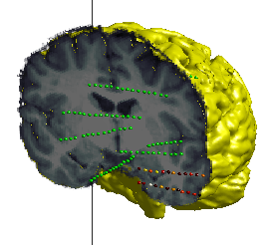

* 1. **Axes settings**

This checkbox allows the colour of the axes to be changed.

1. **Known Issues**
   1. In Adjustment: Automatic AC selection is fairly temperamental. If anything other then a fine-cut MRI is supplied to the automatic AC selection it will fail. Manual selection is preferred in all cases.
   2. In Adjustment: The 2D viewer used for reorientation is still an SPM window not our own implementation.
   3. In 2 Dimensional Viewing: The range sliders are integers only. This means that the ranges (especially for Z-score maps in SPECT) are rounded to the nearest integer.
   4. In 2 Dimensional Viewing: All 2D image panels are globally linked. There is no button to disable global linking. The variable is passed around in the display engine, however no button has been implemented.
   5. In 3 Dimensional Viewing: The range sliders are integers only. This means that the ranges (especially for Z-score maps in SPECT) are rounded to the nearest integer.
   6. In 3 Dimensional Viewing: The range for volume display is simplified as a percentage and is unsuitable for some image types. A range slider should be implemented, however space is limited and a range slider cannot fit comfortably.
   7. In 3 Dimensional Viewing: The connection option for ROI’s has not been finished. An “electrode” option was designed which would build straight prisms (to emulate the physical electrodes used in SEEG) from two or more ROIs with identical designators rather then plot the individual ROI points. This however has not been included.